
Riphah International University
Faculty of Computing (WISH)
Object oriented programming

Lab # 01

Submitted to: Nayab Khalid
Submitted by: Warisha Shakeel Abbasi
Sap id: 80127

Task no.1
Create a function float calculateAverage that receives an integers array and its size and return the average of an element. In main () ask the user for the number of elements, confirm that it is positive, call the average and display the average.
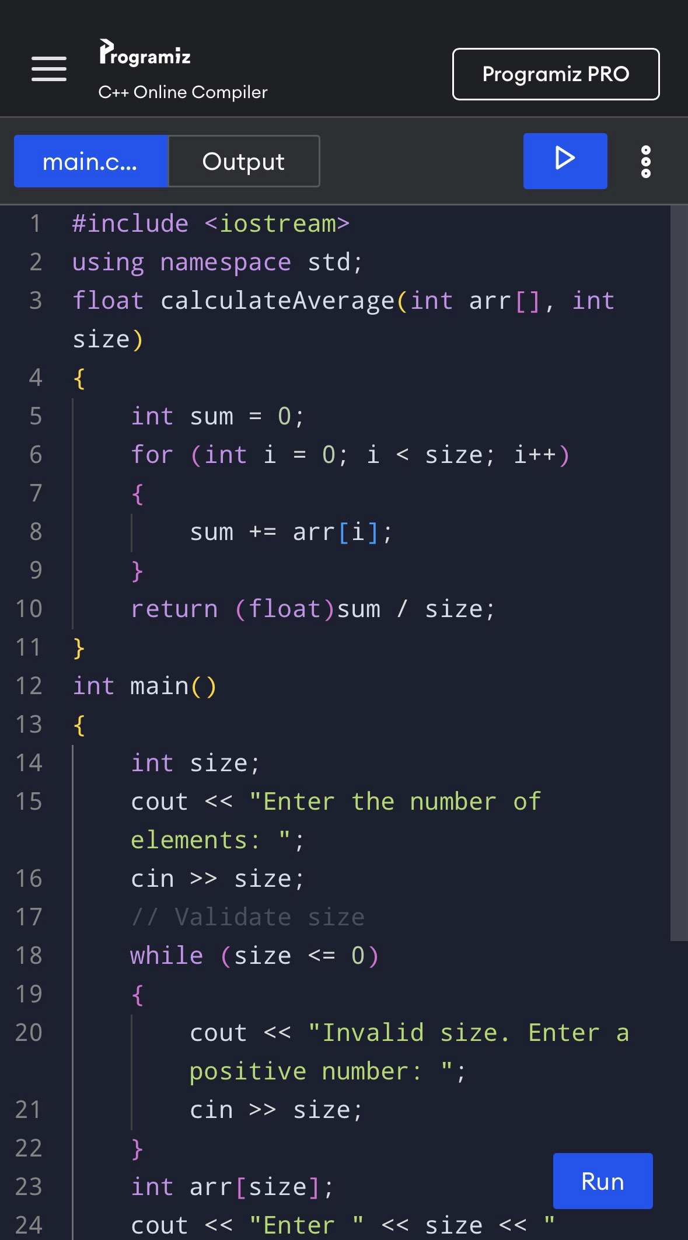
Program:
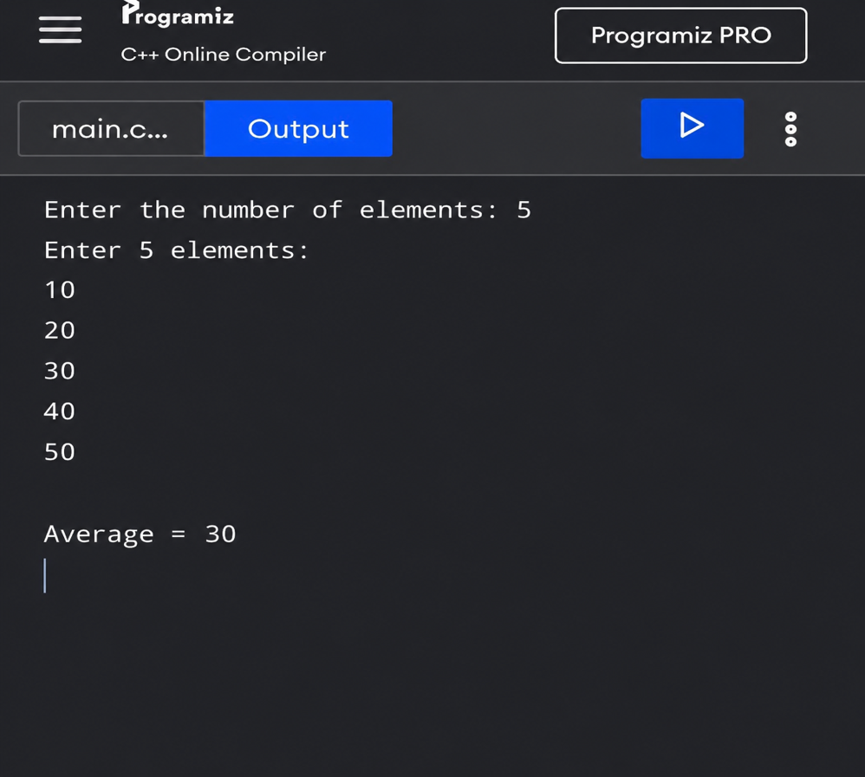
Result:
Task no.2
Define a Student struct with string name, int rollNumber, and float marks. Create an array of three Student structs, input the information for each student, and display all records.
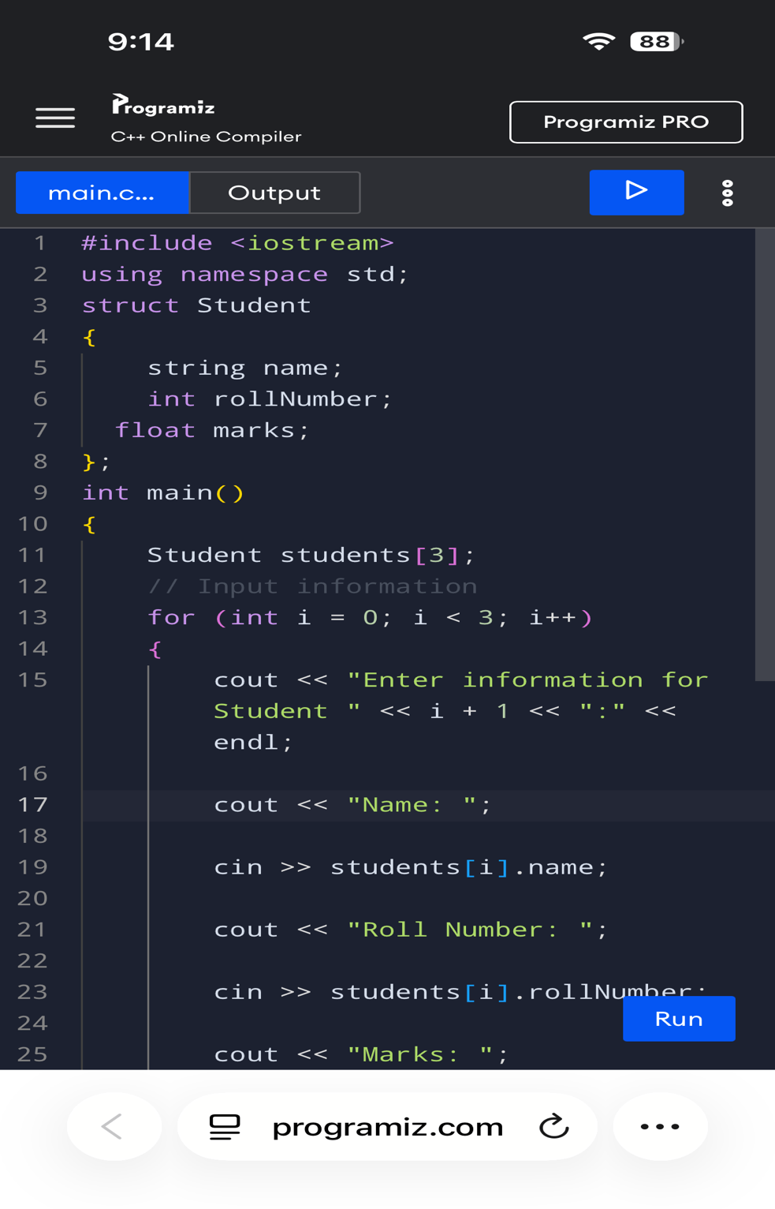
Program:
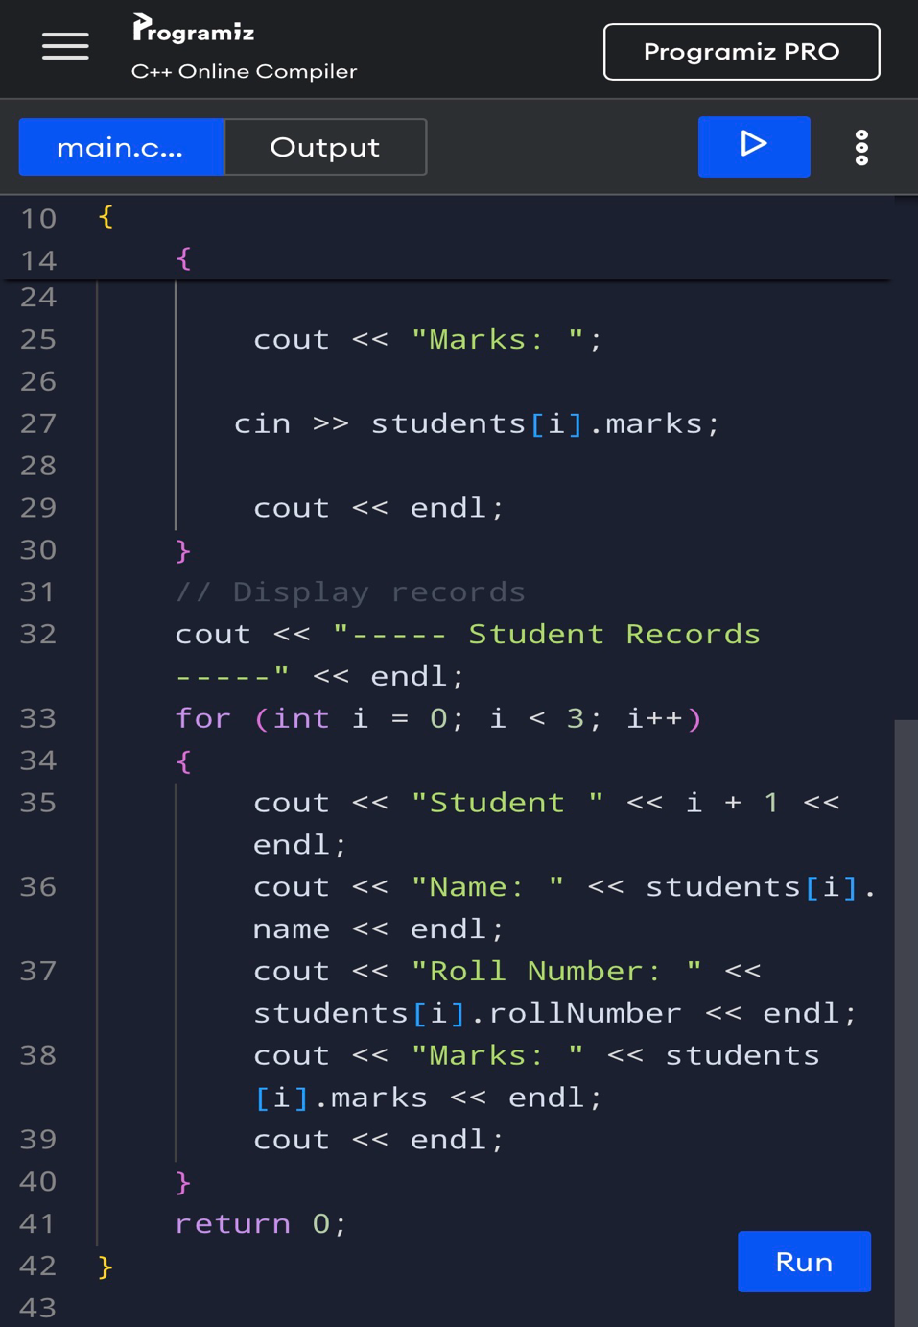

Result:
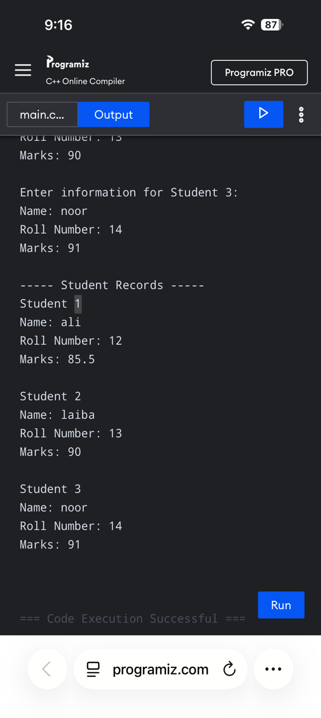
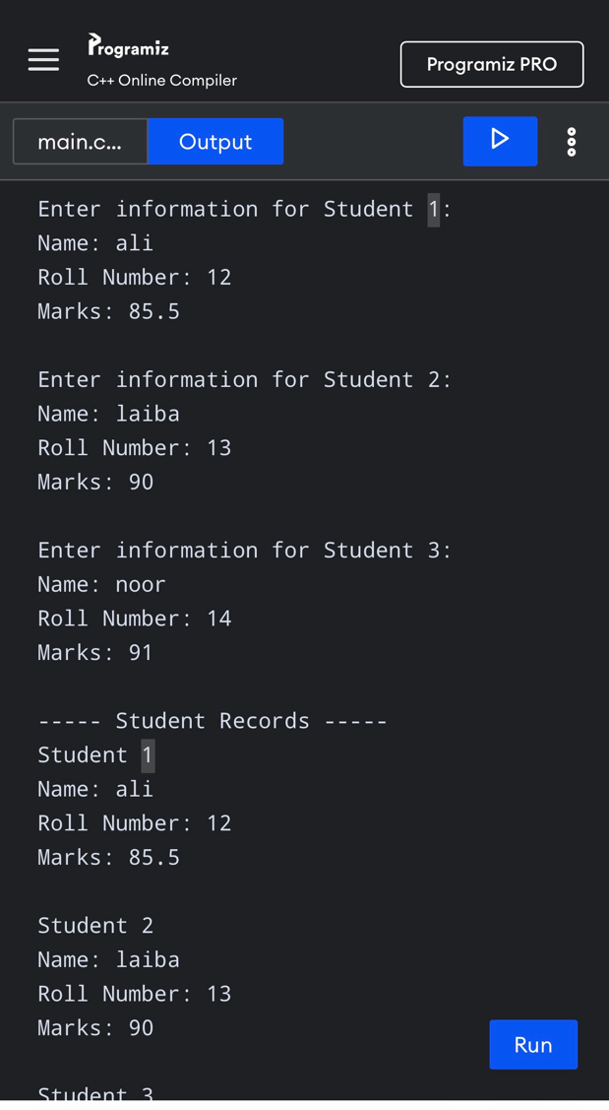
Task no.3
Write a C+t program that asks the user to enter a number and checks whether the number is positive, negative, or zero. Use appropriate conditional statements to make the decision and display the result.

Program:

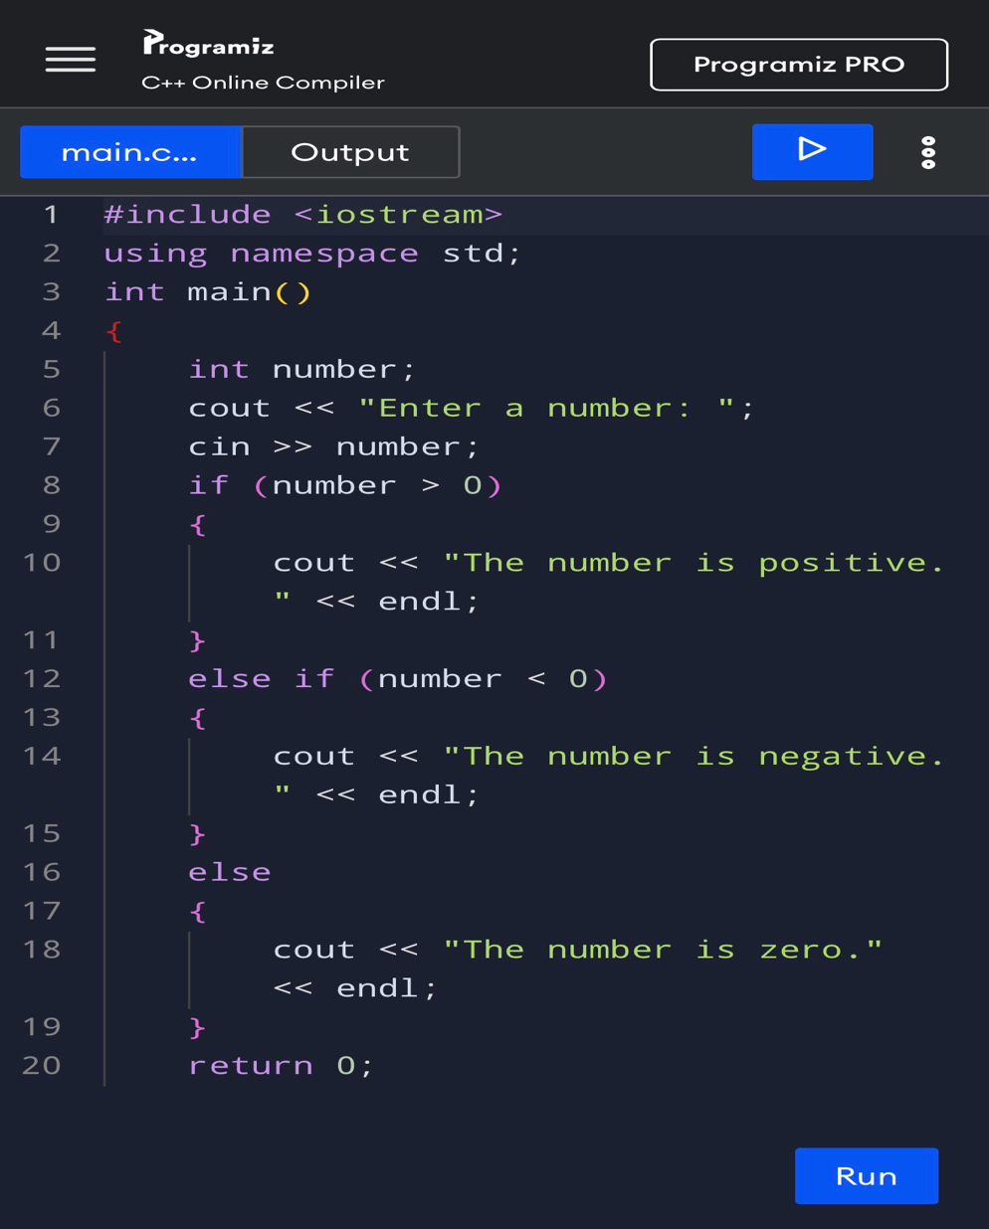

Result:
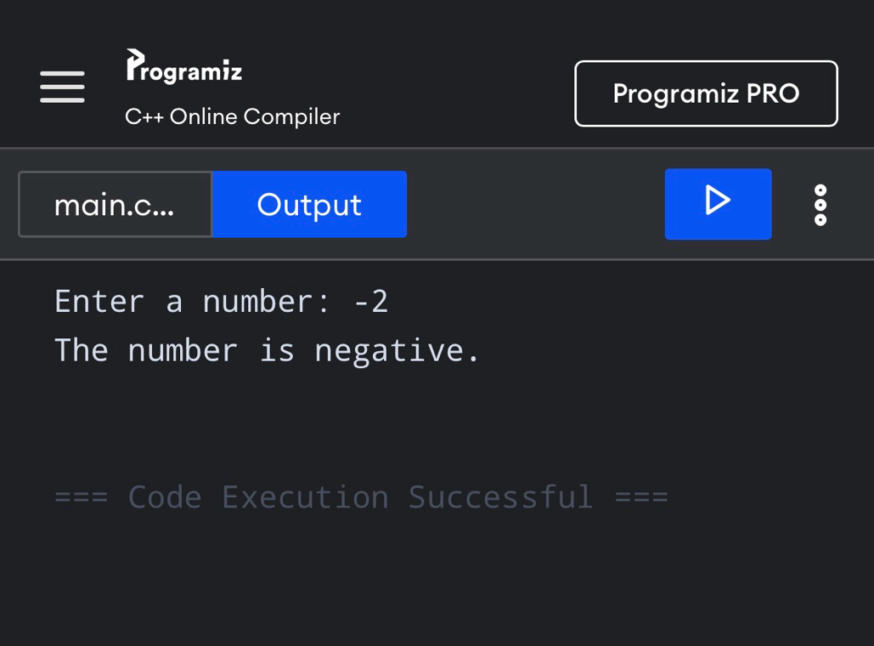
Task no .4
Write a C++ program that stores five integers in an array and creates a function int findMaximum(int arr], int size to find and return the largest element in the array. In main, input the elements, call the function, and display the largest number.

Program:

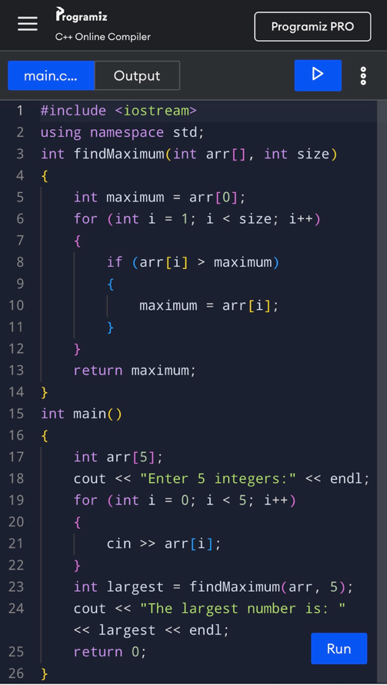
Result:


